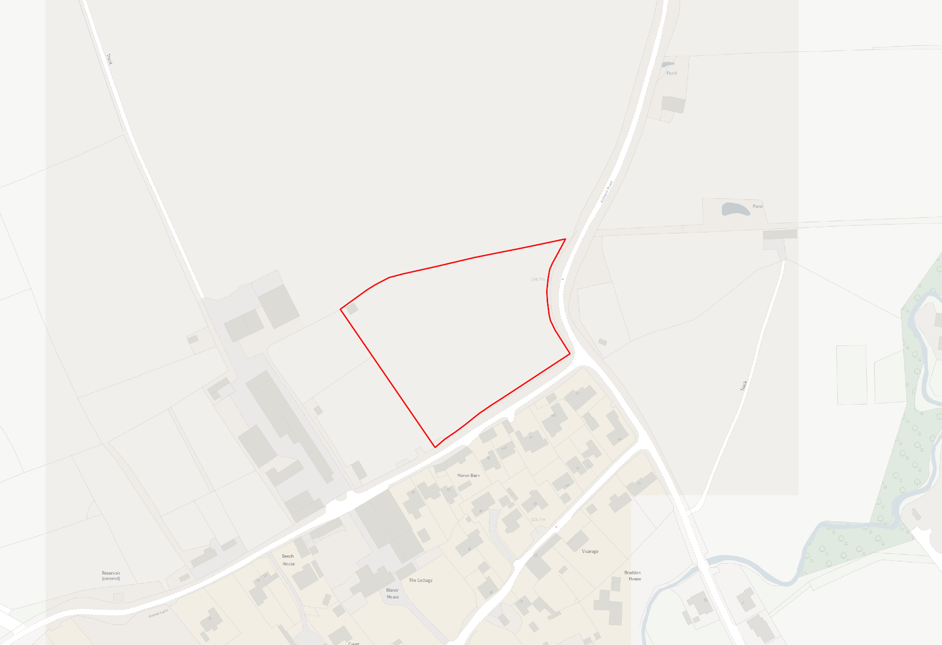
5330 – Residential – Indicative 29 dwellings - Manor Lane, Langham

6605 – Employment – 6.48ha - Land Wireless Hill, South Luffenham
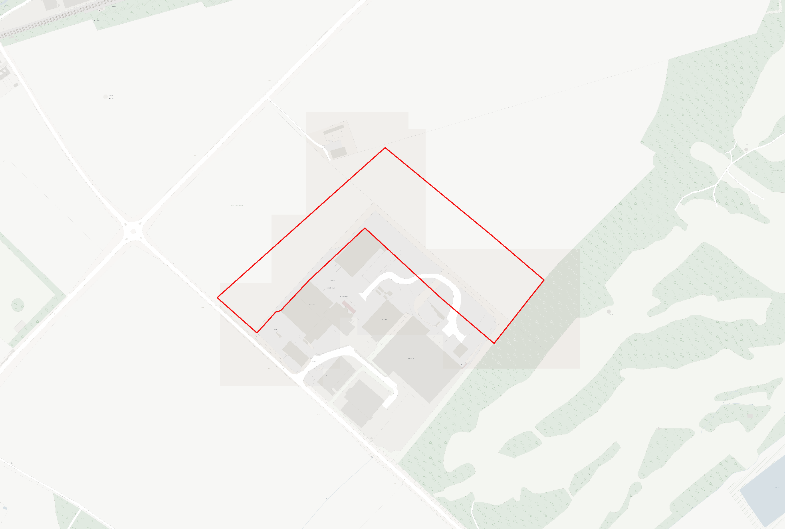
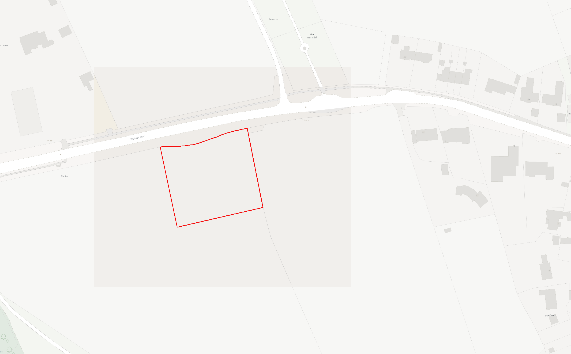
8030 – Residential/Employment (New GP Surgery) - Land South of Whitwell Road, Empingham – In conjunction with Reserve Site H1.c
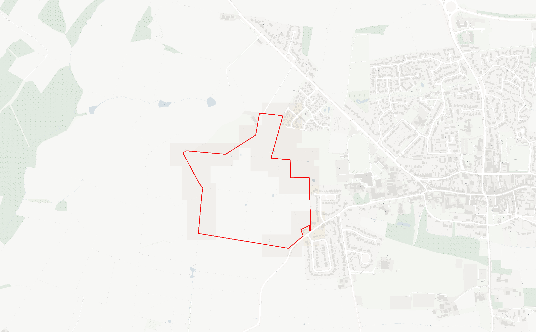
8032 – Residential – Indicative 443 dwellings - Land off Stockerston Road, Uppingham
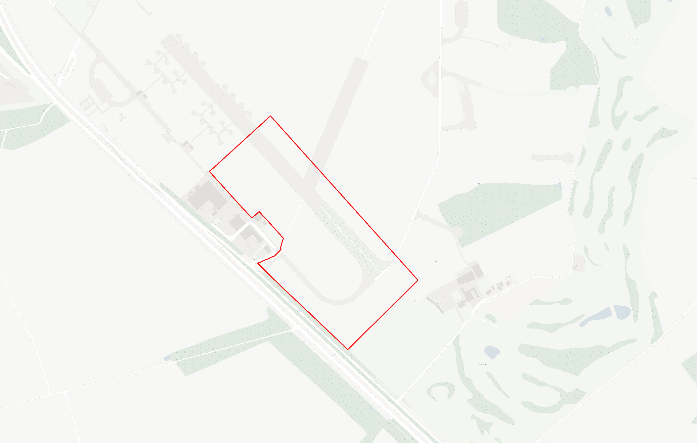
8033 – Employment – 21.2ha - Woolfox Employment
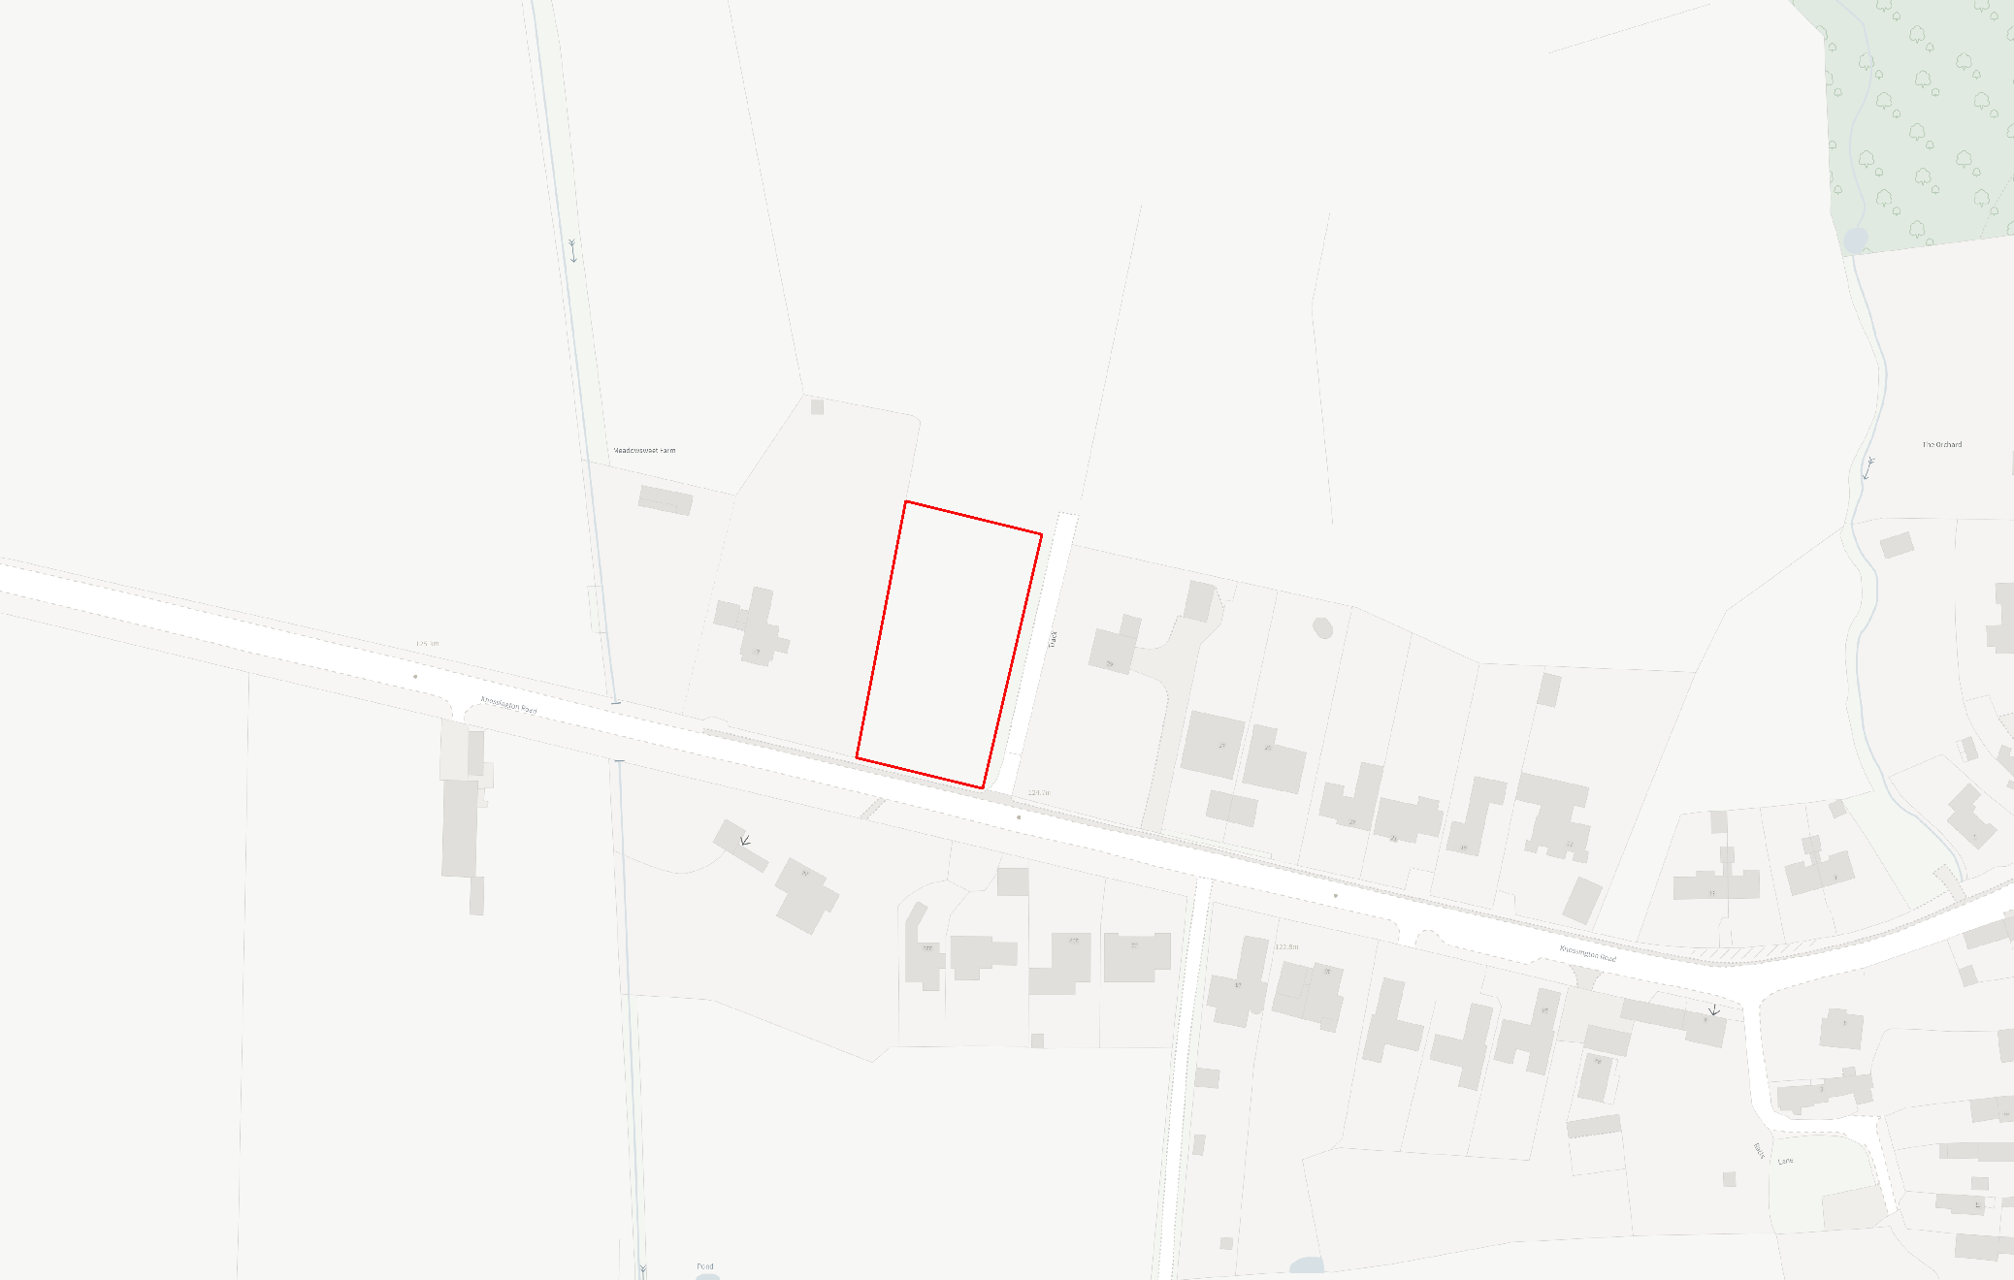
8036 – Residential – Indicative 7 dwellings - Land off Knossington Road, Braunston
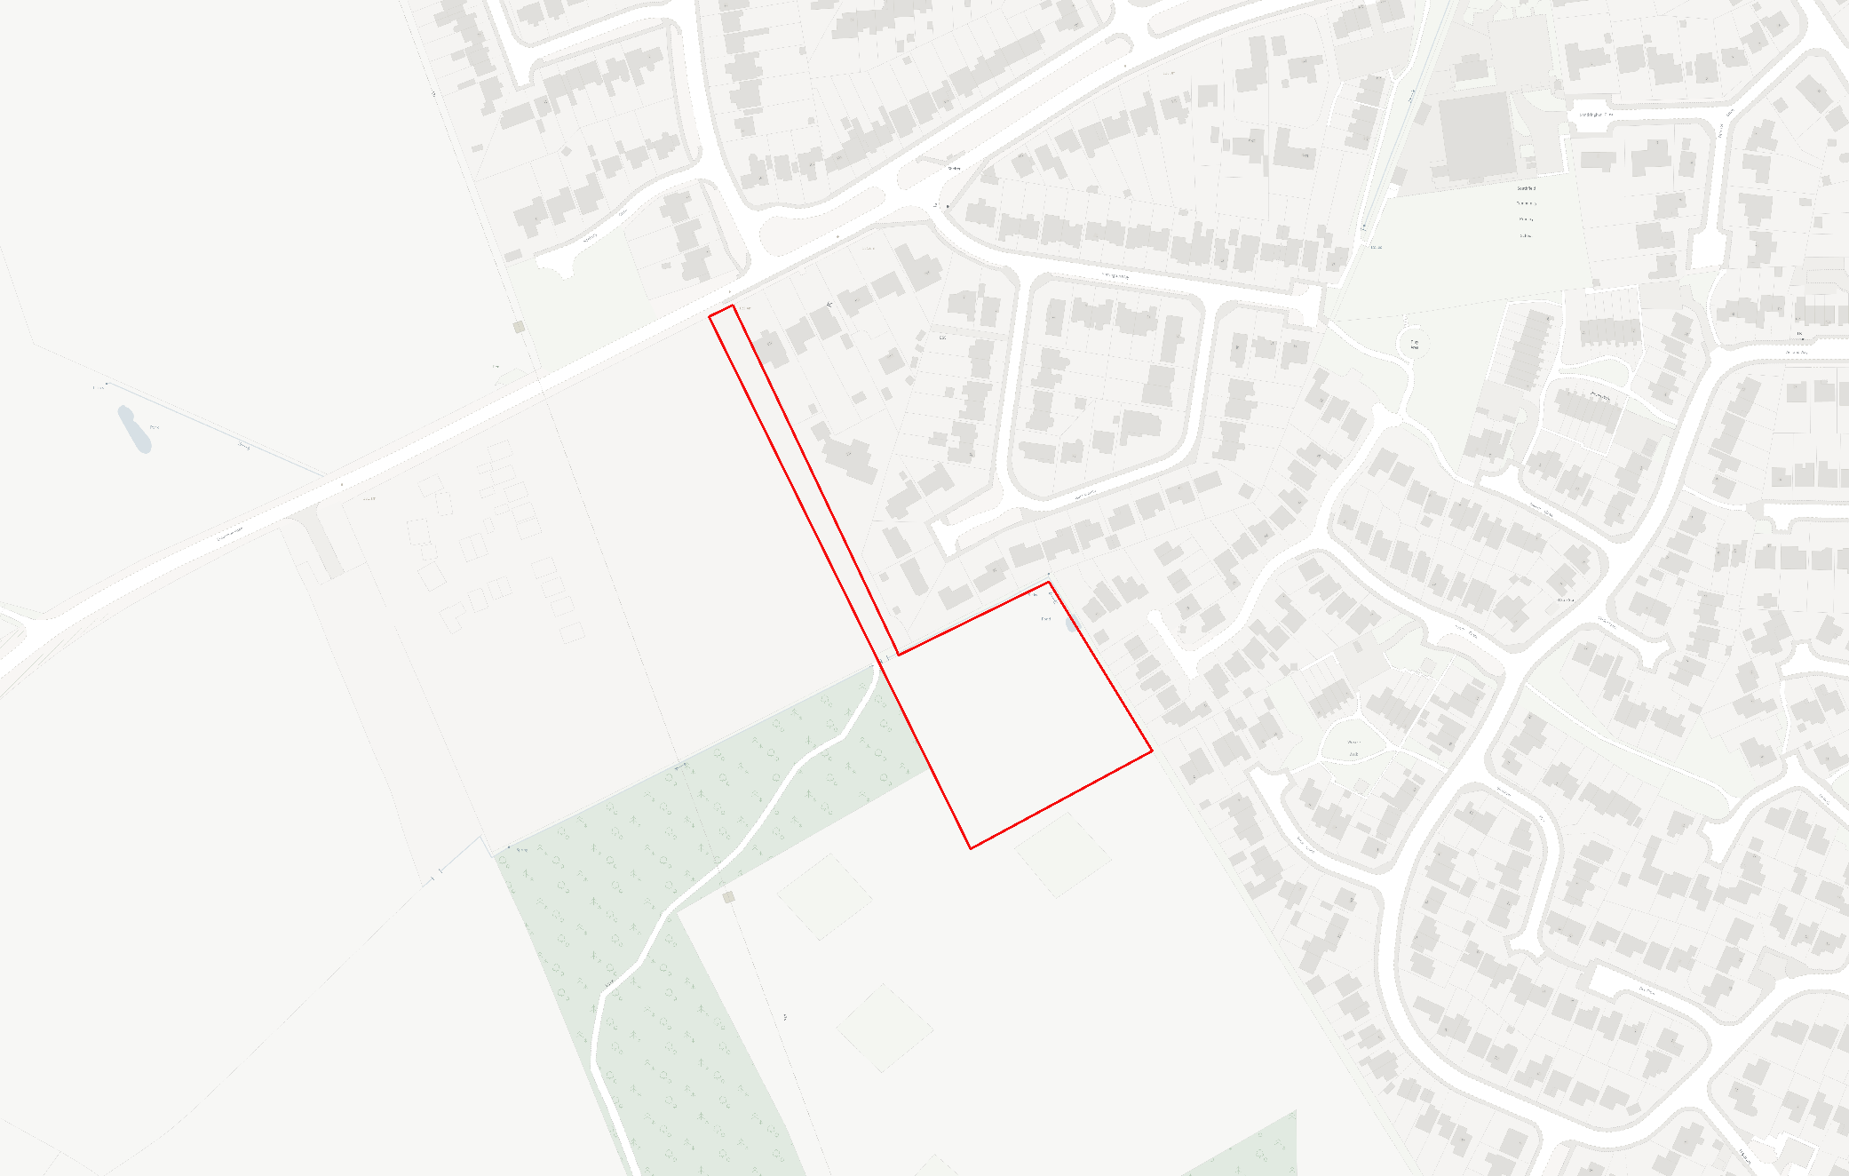
8039 – Residential – Indicative 24 dwellings - Land off Braunston Road, Oakham

